Day 8: 21 Sep. 25

**Creating simple REST full Web service with Products array variables**

Create the folder as **SimpleRestAPI**

npm init -y package.json

npm install express

Open the folder inside a VS Code

**Creating Rest API for Product with Array concept or file or database.**

**Array concept**

1. **Get method : get the resources** 
   1. Get all product in json format : select query
   2. Get particular product base upon some property like pid, pname, price
      1. Query param

URL?key=value

URL?key1=value1&key2=value2

* + 1. Path param

URL/value

URL/value1/value2

Select query with where clause

1. **Post method : create the resource** 
   1. store the product details in array or file system or database

insert query

Post method data send through body part in different format like json or xml etc.

By default express js can’t extract body data from request object we need to use middleware.

Testing through post man client

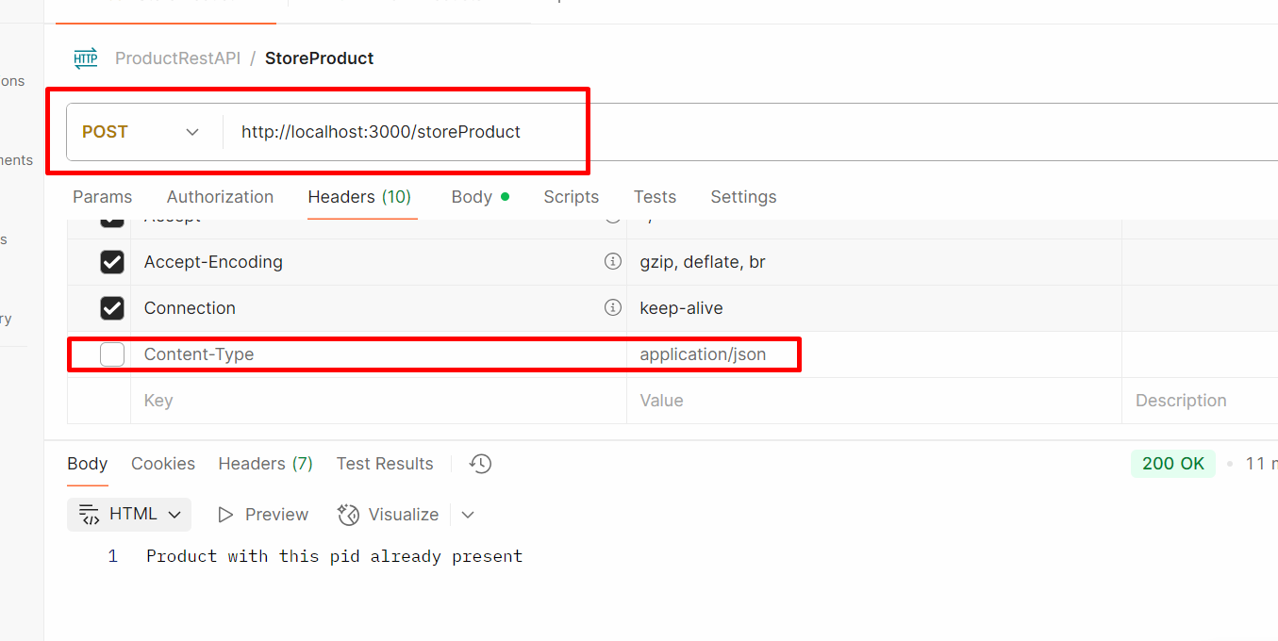

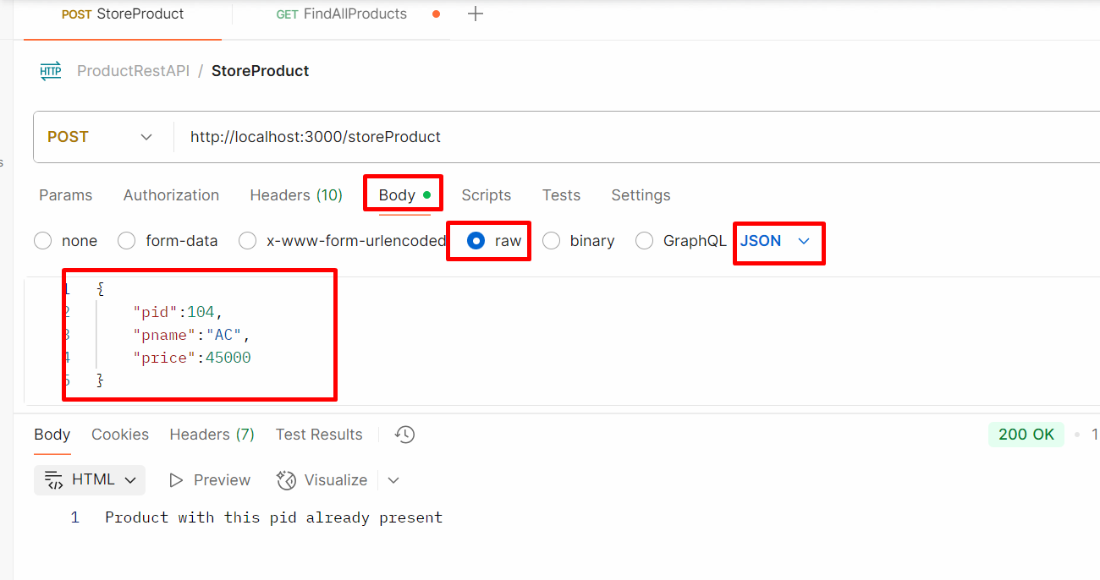

1. **Put method : update the existing resource**
   1. Update the product price using pid

Update query

1. **Delete method : delete the resource** 
   1. Delete the product using pid

Delete query

**To test these end or rest api we need some rest api plugin.**

**Post Man plugin**

**Only Get method we can test through browser.**

**Creating REST API for product object with array concept**

Create the folder **product-rest-api**

**npm init -y**  create the package.json file

**npm install express**

